**Day 4**

NAME :**y.v.satwik**

REG NO :192110129

COURSE :SOFTWARE ENGINEERING

CODE :CSA1001

FACULTY :DR.MARY VALANTINA.G

DATE :29/09/22

LAB MANUAL 18 to 25

**EXPERIMENT :18**

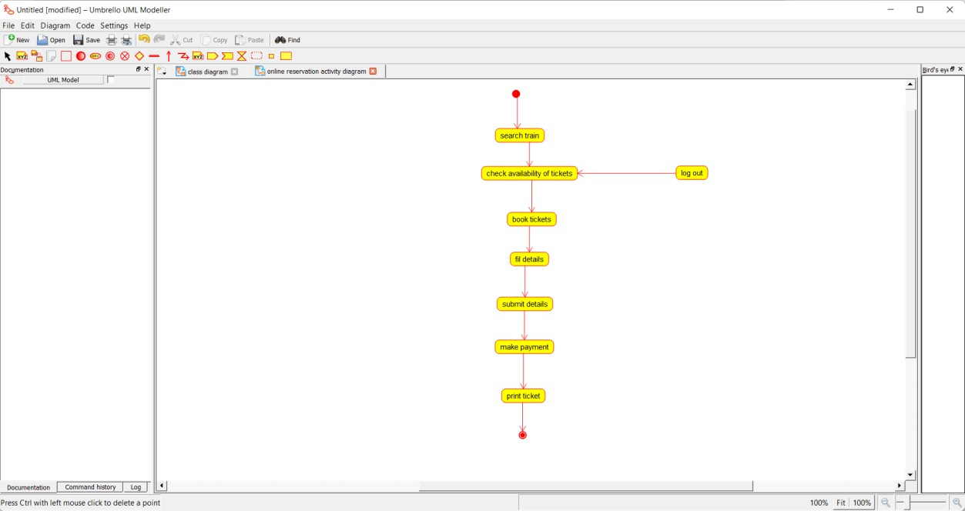

**EXPERIMENT :19**

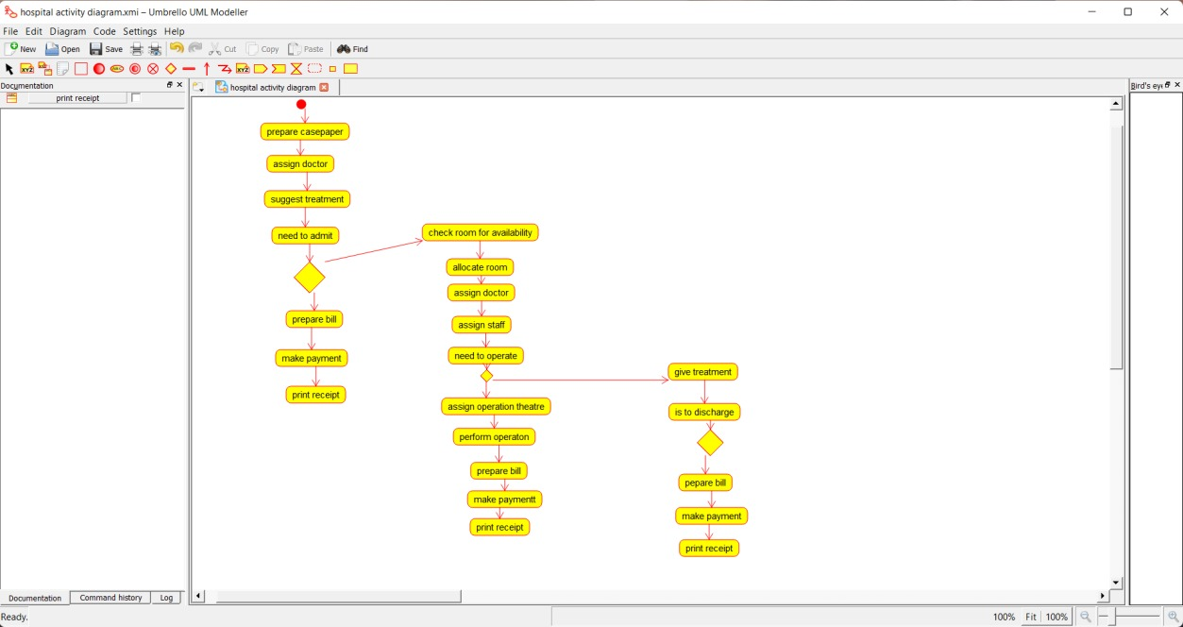

**EXPERIMENT :20**

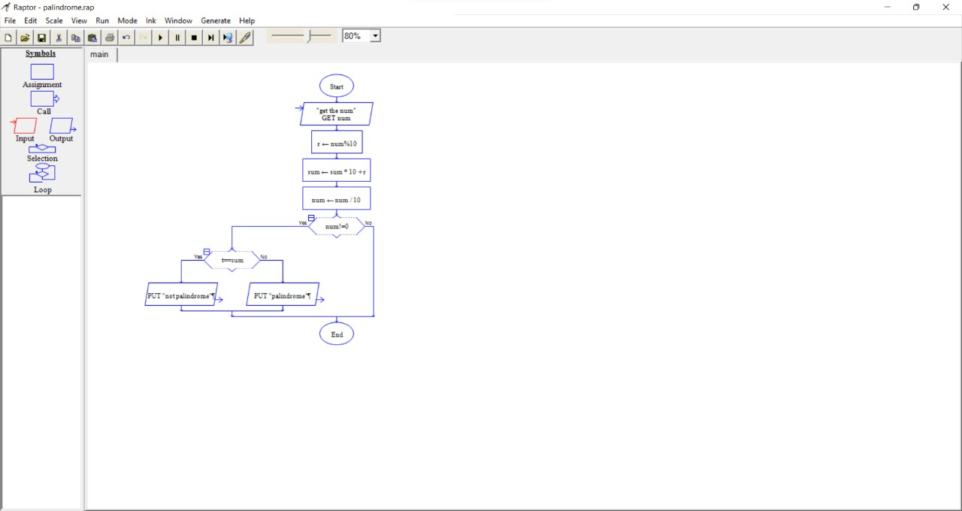

**EXPERIMENT :21**

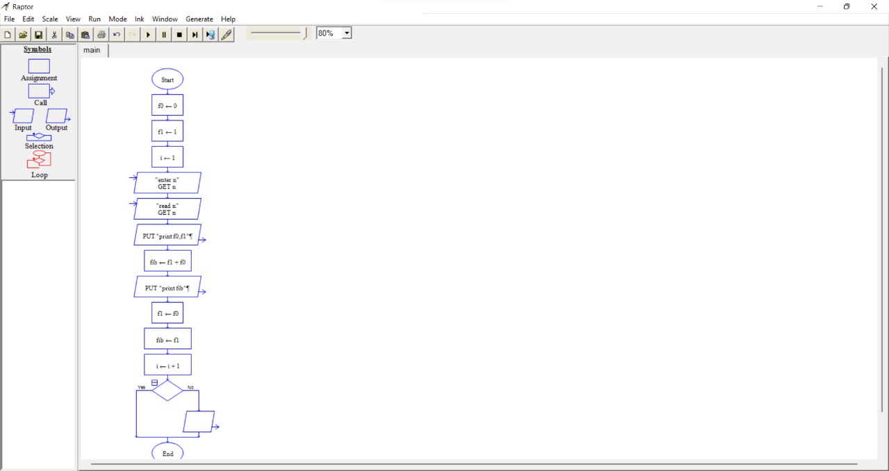

**EXPERIMENT :22**

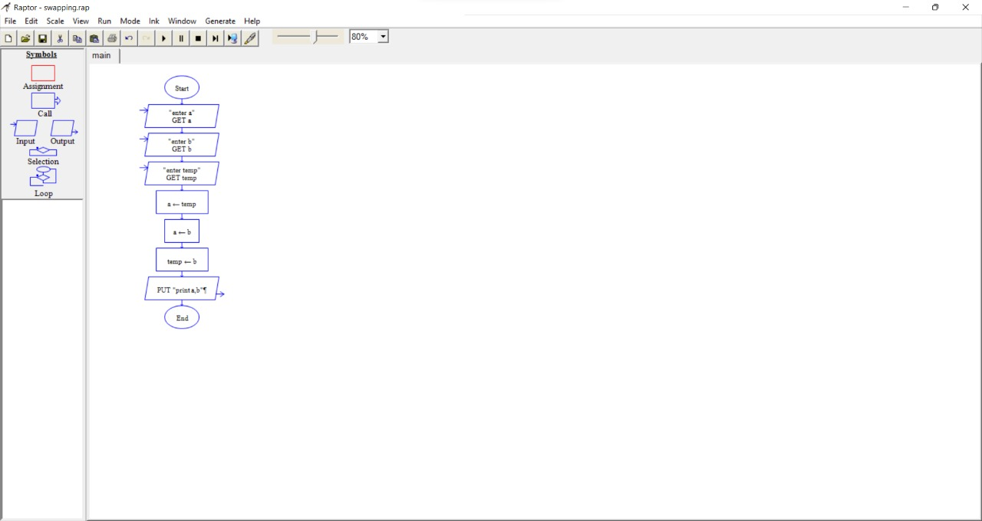

**EXPERIMENT :23**

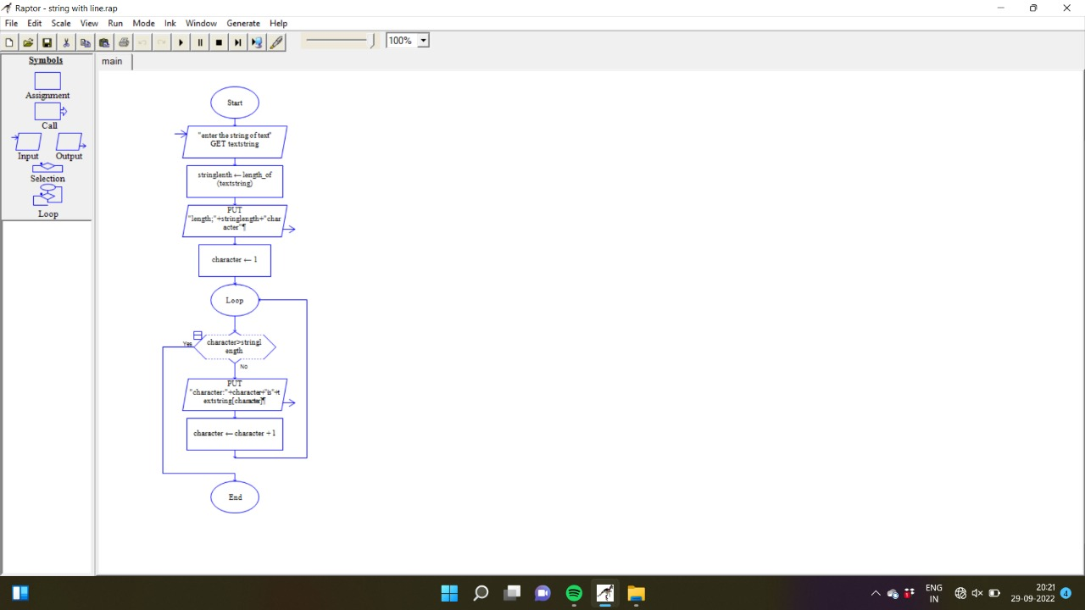

**EXPERIMENT :24**

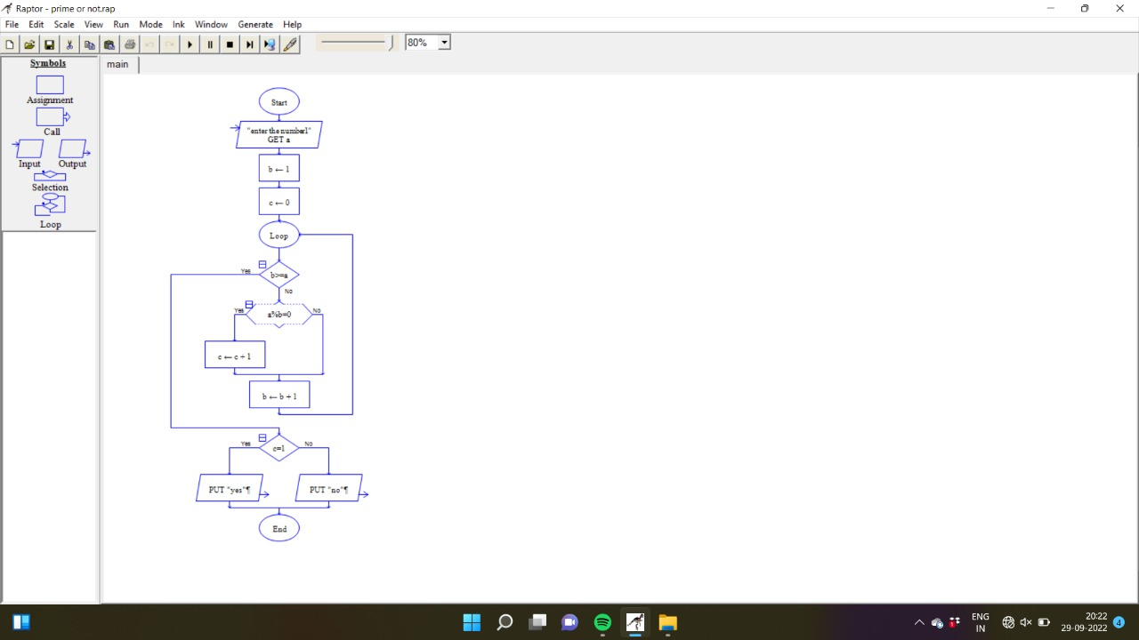

**EXPERIMENT :25**

